What class of lever is this?

What class of lever is this?
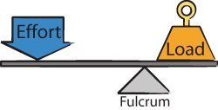

What class of lever is this?



What class of lever is this?
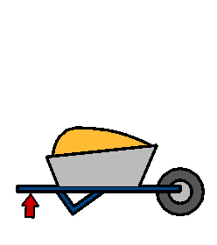

What class of lever is this?

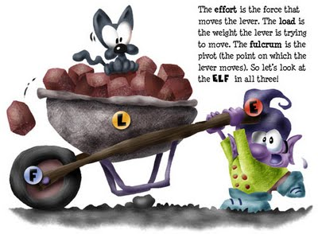

What class of lever is this?
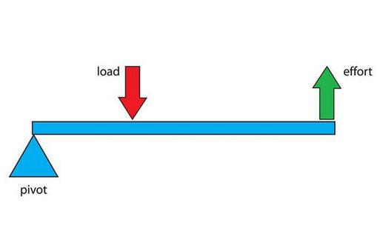
What class of lever is this?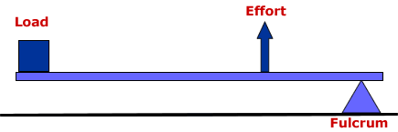
What class of lever is this?
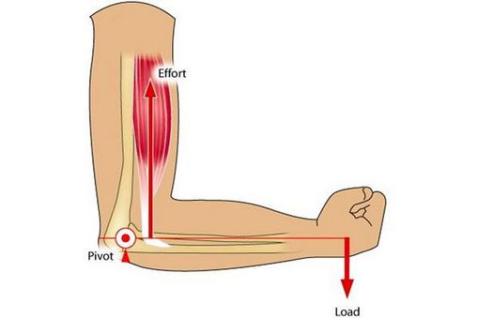

What is the equation for calculating forces using levers

What does every simple machine have in common?

Class one

Class one

Class Two

Class one

Class Two

Class Two

Class Three

Class Three

Every simple machine exchanges force for distance.

M * D = M * D
Mass times lever arm is equal to mass times the lever arm.

